**WORK IN CLASS N°1**

**Date:** 15/05/2023

**Members:**

* DENNYS ALEXANDER PUCHA CARRERA.
* JOSÉ ANDRES LAPO CAMPOVERDE.
* MÓNICA JANETH PADILLA MALLA.
* SULAY KATHERINE ORTIZ ESTRELLA.

**EXERCISE N° 1**

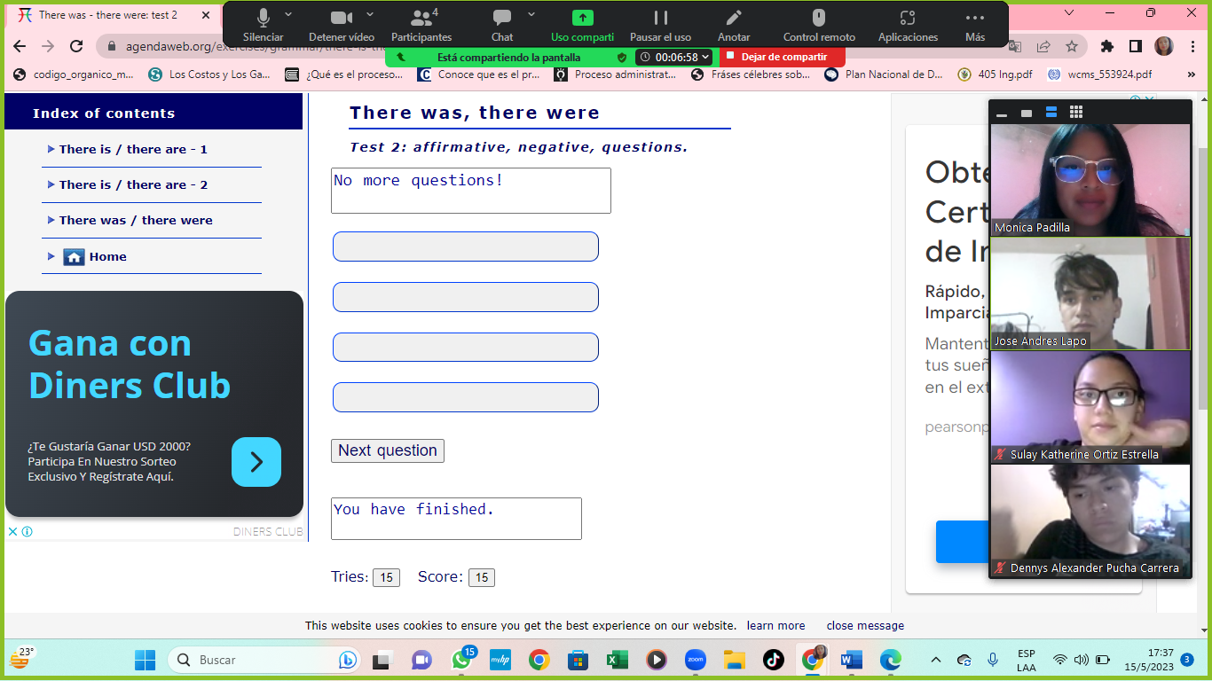

**EXERCISE N° 2**

